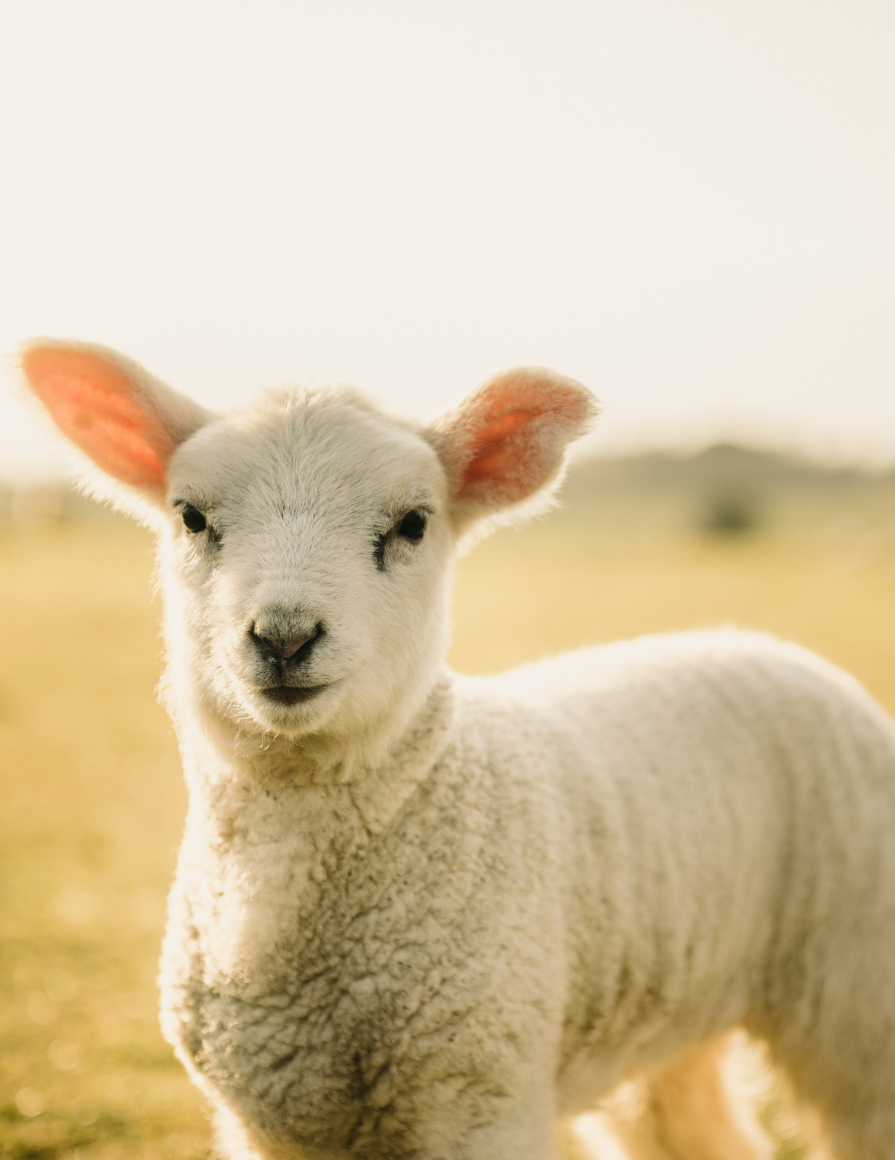
Do not be afraid, little flock,
for your Father has been pleased
to give you the kingdom.
- Luke 12:32

The Ninth Sunday after Pentecost 8/7/2022

Order of Service: Setting Two, page 172
Opening Hymn: 799 I Leave All Things to God's Direction
Confession, pg. 155
Lord, Have Mercy, pg. 156
Prayer of the Day
Almighty and everlasting God, you are always more ready to hear than we to pray and willing to give far more than we either desire or deserve. Pour upon us the abundance of your mercy, forgiving us those things of which our conscience is afraid, and giving us those good things for which we are not worthy to ask except through the merits and mediation of your Son, Jesus Christ our Lord, who lives and reigns with you and the Holy Spirit, one God, now and forever.
First Reading Genesis 15:1-6
Second Reading Hebrews 11:1-3,8-16
Gospel Acclamation, pg. 179
Gospel Reading Luke 12:22-34
Hymn of the Day: 868 By Faith
Sermon
Nicene Creed, pg. 180
Offering
The Sacrament, pg. 183
Distribution Hymn: 662 Draw Near
Distribution Hymn: 839 Rock of Ages, Cleft for Me
Blessing, pg. 187
Closing Hymn: 835 Precious Lord, Take My Hand

1st Reading: Genesis 15:1-6
After this, the word of the Lord came to Abram in a vision:
“Do not be afraid, Abram. I am your shield, your very great reward.
² But Abram said, “Sovereign Lord, what can you give me since I remain childless and the one who will inherit my estate is Eliezer of Damascus?” ³ And Abram said, “You have given me no children; so a servant in my household will be my heir.”
⁴ Then the word of the Lord came to him: “This man will not be your heir, but a son who is your own flesh and blood will be your heir.” ⁵ He took him outside and said, “Look up at the sky and count the stars—if indeed you can count them.” Then he said to him, “So shall your offspring be.”
⁶ Abram believed the Lord, and he credited it to him as righteousness.

2nd Reading: Hebrews 11:1-3,8-16
Now faith is confidence in what we hope for and assurance about what we do not see. ² This is what the ancients were commended for.
³ By faith we understand that the universe was formed at God’s command, so that what is seen was not made out of what was visible.
⁸ By faith Abraham, when called to go to a place he would later receive as his inheritance, obeyed and went, even though he did not know where he was going. ⁹ By faith he made his home in the promised land like a stranger in a foreign country; he lived in tents, as did Isaac and Jacob, who were heirs with him of the same promise. ¹⁰ For he was looking forward to the city with foundations, whose architect and builder is God. ¹¹ And by faith even Sarah, who was past childbearing age, was enabled to bear children because she considered him faithful who had made the promise. ¹² And so from this one man, and he as good as dead, came descendants as numerous as the stars in the sky and as countless as the sand on the seashore.
¹³ All these people were still living by faith when they died. They did not receive the things promised; they only saw them and welcomed them from a distance, admitting that they were foreigners and strangers on earth. ¹⁴ People who say such things show that they are looking for a country of their own. ¹⁵ If they had been thinking of the country they had left, they would have had opportunity to return. ¹⁶ Instead, they were longing for a better country—a heavenly one. Therefore God is not ashamed to be called their God, for he has prepared a city for them.
Gospel Reading: Luke 12:22-34
²² Then Jesus said to his disciples: “Therefore I tell you, do not worry about your life, what you will eat; or about your body, what you will wear. ²³ For life is more than food, and the body more than clothes. ²⁴ Consider the ravens: They do not sow or reap, they have no storeroom or barn; yet God feeds them. And how much more valuable you are than birds! ²⁵ Who of you by worrying can add a single hour to your life? ²⁶ Since you cannot do this very little thing, why do you worry about the rest?
²⁷ “Consider how the wild flowers grow. They do not labor or spin. Yet I tell you, not even Solomon in all his splendor was dressed like one of these. ²⁸ If that is how God clothes the grass of the field, which is here today, and tomorrow is thrown into the fire, how much more will he clothe you—you of little faith! ²⁹ And do not set your heart on what you will eat or drink; do not worry about it. ³⁰ For the pagan world runs after all such things, and your Father knows that you need them. ³¹ But seek his kingdom, and these things will be given to you as well.
³² “Do not be afraid, little flock, for your Father has been pleased to give you the kingdom. ³³ Sell your possessions and give to the poor. Provide purses for yourselves that will not wear out, a treasure in heaven that will never fail, where no thief comes near and no moth destroys. ³⁴ For where your treasure is, there your heart will be also.

