ORDER OF SERVICE

PRAYER AT THE CLOSE OF DAY
Compline: Setting II
“Prayer at the Close of Day” is a version of the historic rite called Compline. It is the final service of the day before one retires for the night. The congregation gathers in silence. Preservice music is omitted, and the lighting is subdued. This is a time for prayer and meditation. The believer finds peace in God’s forgiveness and security under the shadow of his wings.
It is customary for the leader to remain seated while leading Compline worship. The entire service of Compline is conducted in a calm and relaxed manner. The pace of the service is slow and meditative. Musical selections reflect this character.
OPENING HYMN
L: Blessed are you, O Lord, the God of our fathers, Creator of the changes of day and night, giving rest to the weary, renewing the strength of those who are spent, giving us reason to sing in the evening. As you have protected us in the day that has passed, so be with us in the coming night. Keep us from every sin, every evil, and every fear, for you are our light and salvation and the strength of our life. To you be the glory for endless ages. Amen.

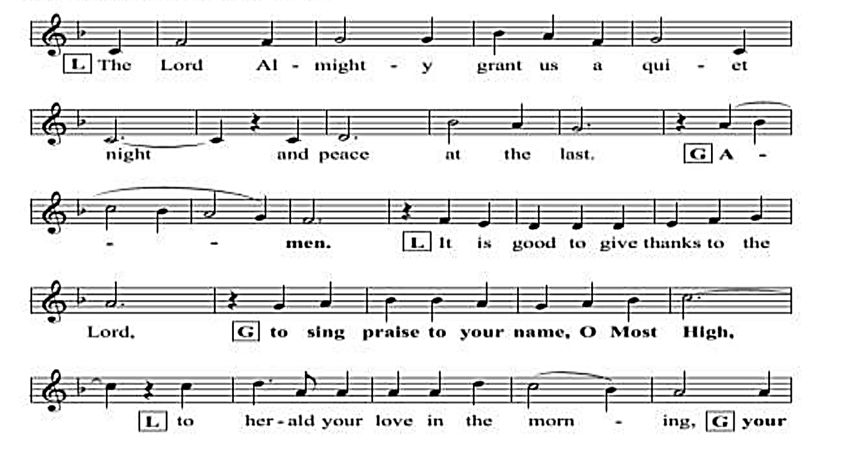

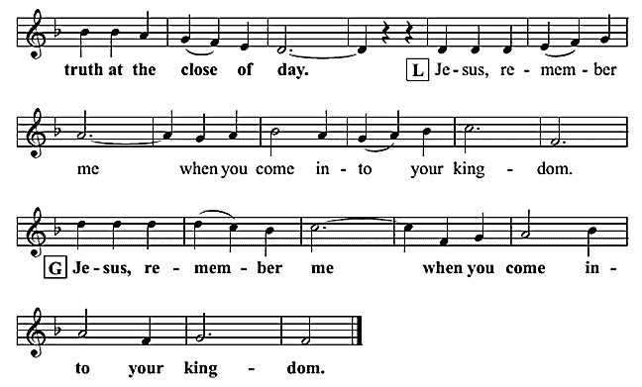

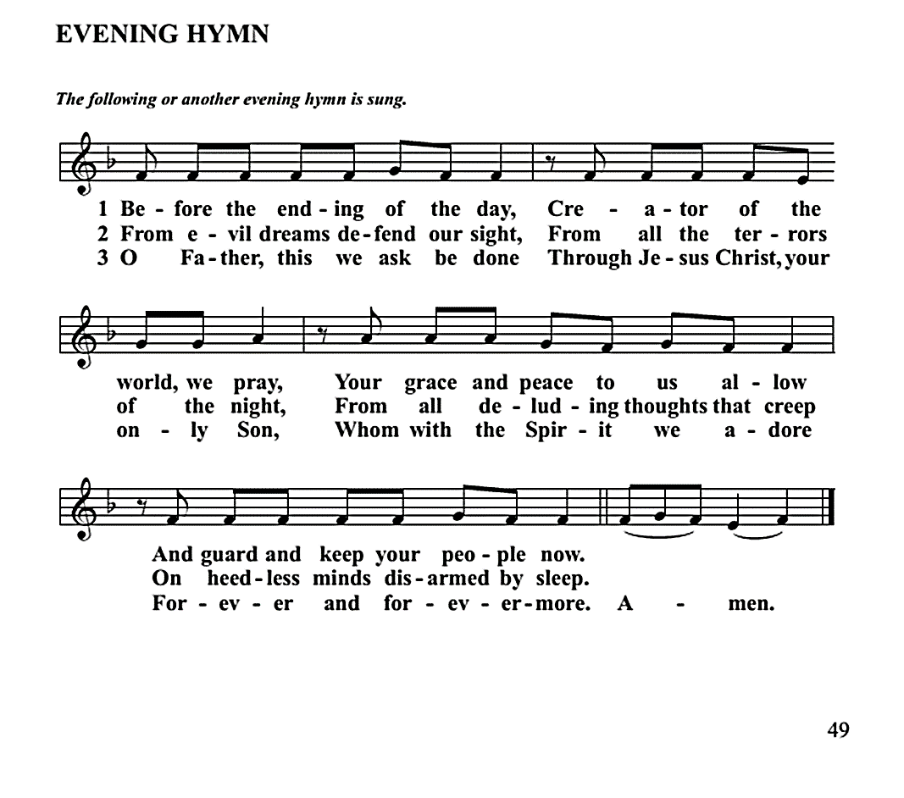

PSALM OF THE EVENING

AN EVENING PRAYER
L: Lord God, our refuge and fortress, your faithfulness has protected us through this day. Now send your Holy angels to guard us from danger through this night. Give us peaceful rest, free from fear that we may wake refreshed to serve you, through Jesus Christ your Son our Lord. Amen.

LESSONS FOR THE EVENING
AN EVENING HYMN
SERMON
OFFERING
PRAYERS
LORD’S PRAYER
Our father in heaven, hallowed be your name. Your kingdom come, your will be done on earth as it is in heaven. Give us today our daily bread. Forgive us our sins, as we forgive those who sin against us. Lead us not into temptation but deliver us from evil. For the kingdom the power and the glory are yours, now and forever. Amen.
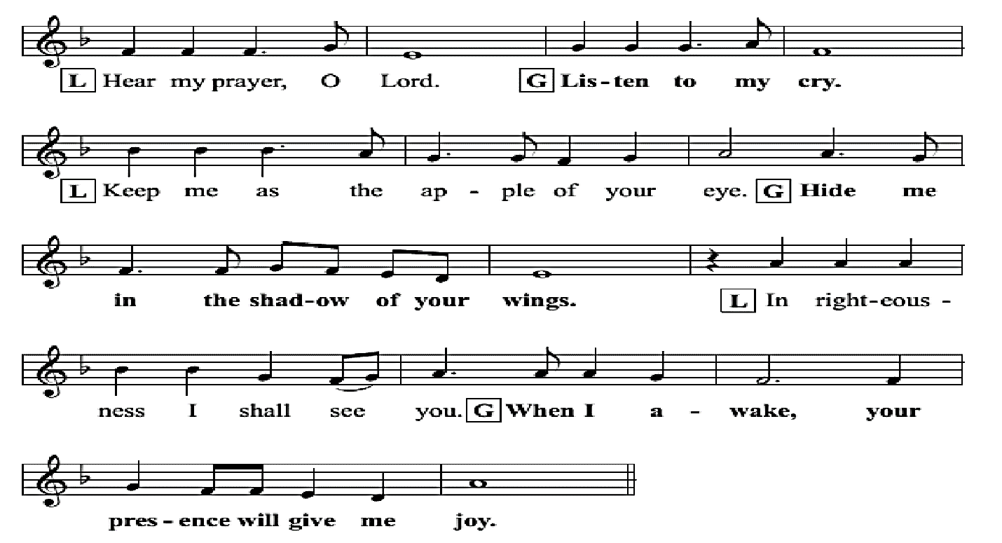
GOSPEL CANTICLE

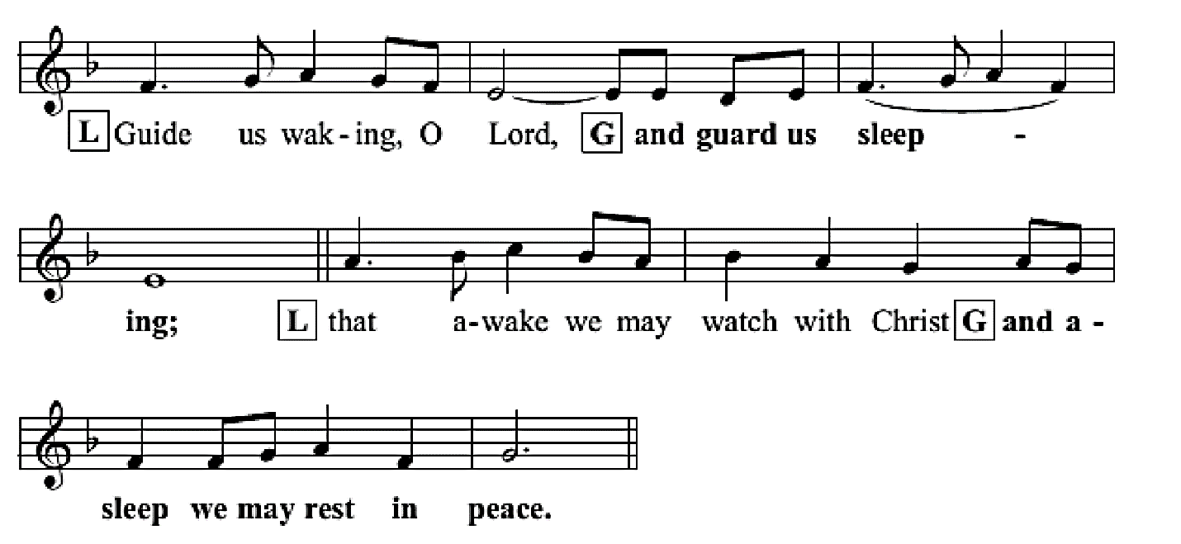

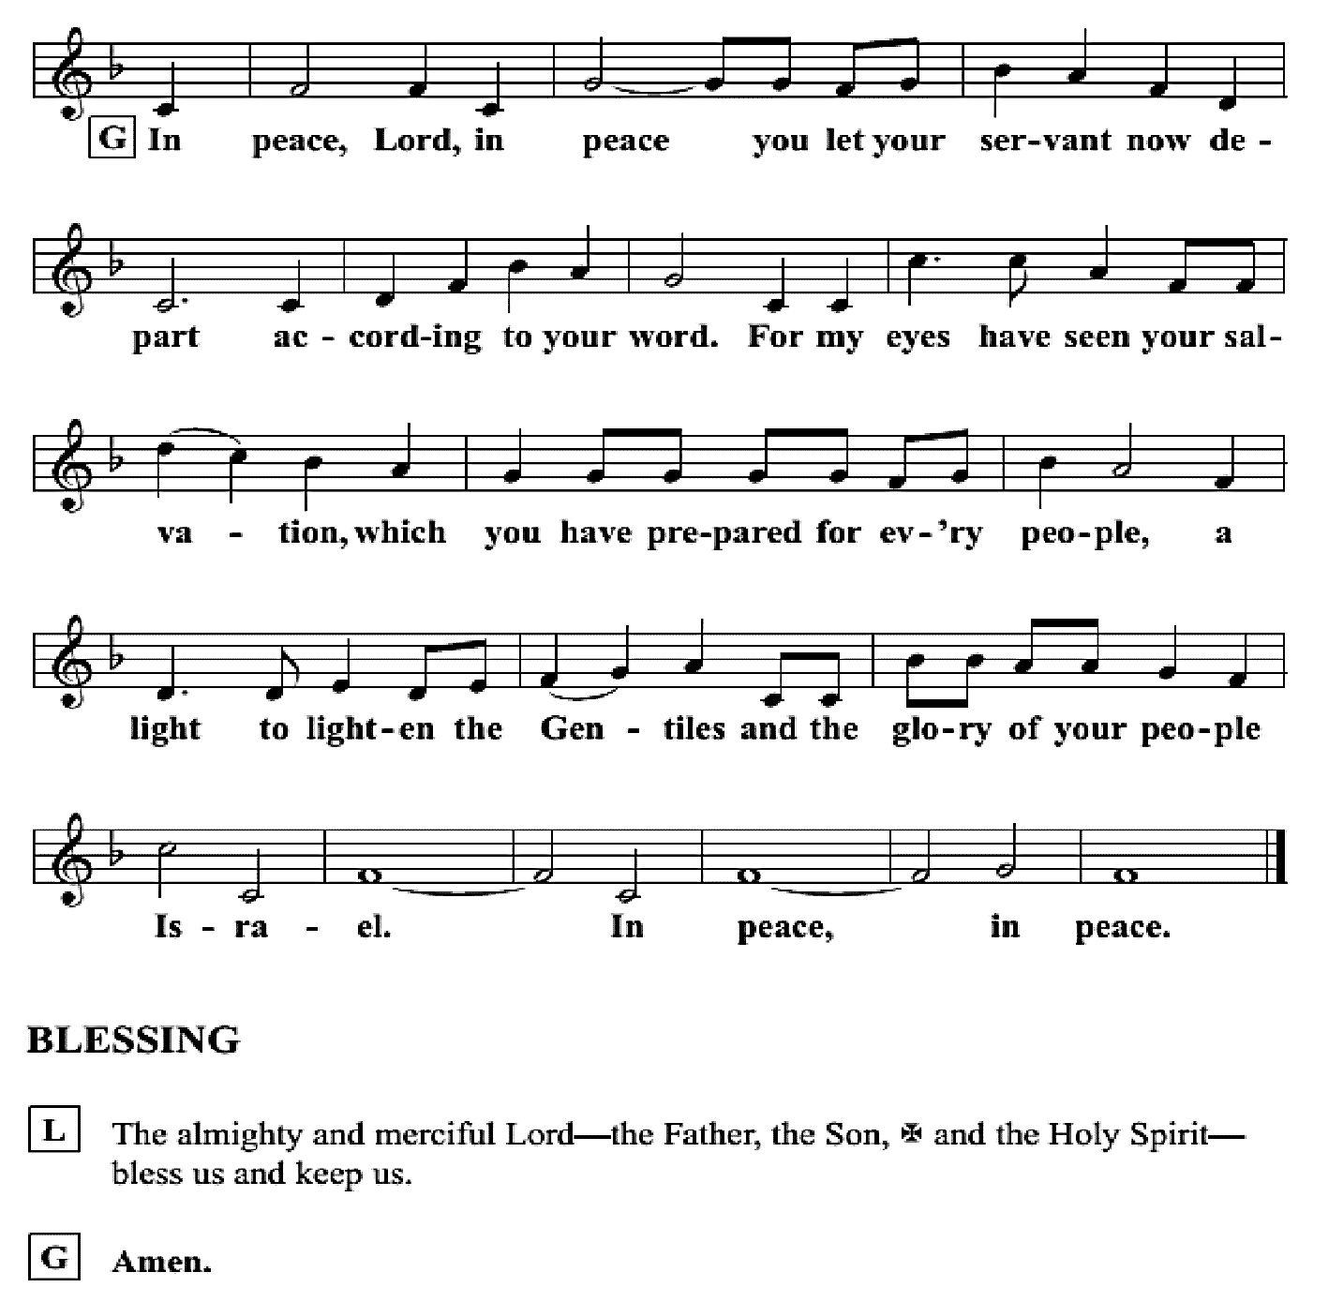

CLOSING HYMN
Please depart from the sanctuary in silence on your time.

