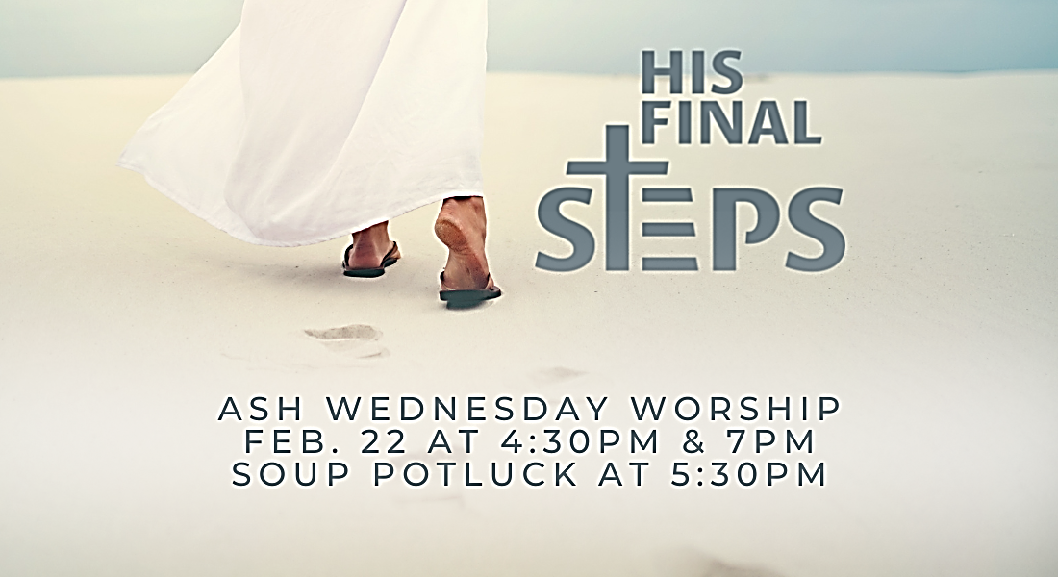

Lenten Midweek Worship Services

Opening Hymn: This is located on the back of the bulletin.
P: In the name of the Father and of the Son
+ and of the Holy Spirit.
C: Amen.

P: O Lord, open my lips.
C: And my mouth shall declare your praise.

P: Hasten to save me, O God.
C: O Lord, come quickly to help me.

P: The Lord be with you.
C: And also with you.

M: Lord God, you have brought us safely to this hour
of evening prayer. We thank you for providing all we
need for body and life. Bless us who have gathered in
your name. Forgive our sins. Speak to our hearts.
Dispel our sorrows with the comfort of your Word, and
receive our hymns of praise, through Jesus Christ our
living Savior, ruling with you and the Holy Spirit.
C: Amen.

Responsive Psalm: This is located on the back of the bulletin.
Passion Reading
Gospel Reading
Confessions of Faith: The Apostle’s Creed
I believe in God, the Father almighty, maker of heaven and earth.
I believe in Jesus Christ, his only Son, our Lord, who was conceived by the Holy Spirit, born of the virgin Mary, suffered under Pontius Pilate, was crucified, died, and was buried. He descended into hell. The third day he rose again from the dead. He ascended into heaven and is seated at the right hand of God the Father almighty. From there he will come to judge the living and the dead.
I believe in the Holy Spirit, the holy Christian Church, the communion of saints, the forgiveness of sins, the resurrection of the body, and the life everlasting. Amen.

Sermon Hymn: This is located on the back of the bulletin.
Sermon
Lord’s Prayer
Our Father in heaven, hallowed be your name,
your kingdom come, your will be done, on earth as in heaven.
Give us today our daily bread.
Forgive us our sins, as we forgive those who sin against us.
Lead us not into temptation, but deliver us from evil.
For the kingdom, the power, and the glory are yours
now and forever. Amen.

Blessing
M: The grace of our Lord Jesus Christ
and the Love of God
and the fellowship of.the Holy Spirit be with you all.
C: Amen.

Closing Hymn: This is located on the back of the bulletin.

March 1st, 2023
Reading: John 11 (selected)
Hymns: 420/654 V.1-4/395
Psalm: 51
Pastor: Otto

March 8th, 2023
Reading: John 12:1-11
Hymns: 394/514/401V.1-4
Psalm: 130
Pastor: Rockhoff

March 15th, 2023
Reading: Mark 11:12-14, 20-25
Hymns: 409/873/560
Psalm: 4
Pastor: Kirschbaum

March 22nd, 2023
Reading: John 12:20-33
Hymns: 703/814 V.1-2&5-6/794
Psalm: 30
Pastor: Rockhoff

March 29th, 2023
Reading: Matthew 21:12-17
Hymns: 402/408/396 V.1-3 & 7
Psalm: 118
Pastor: Otto

